NATIONAL UNIVERSITY OF MODERN LANGUAGE ISLAMABAD
Lab: 02


Submitted to:
Ms Sana Ashraf
Submitted by:
Zulqarnain Hassan
Roll No: …………………… SP21379
Subject: …………………… UXD
Department: ……………… BSSE-6-Afternoon
Date: ………………………13-02-2025

Observation (ptv).
Overall the pakistan television official website was good designed but have some drawbacks.
Drawbacks:(ptv):
- At the home page the three lines at the right top corner was not providing clear information. I was expecting some links but it has two sections about us and contact info
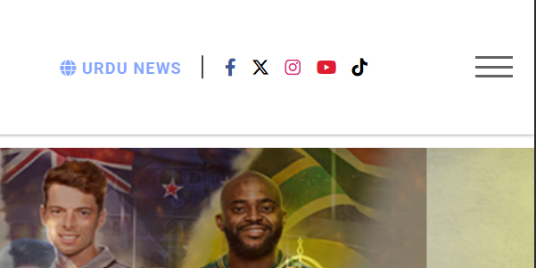

- When the app open in mobile the looks good specially the menu
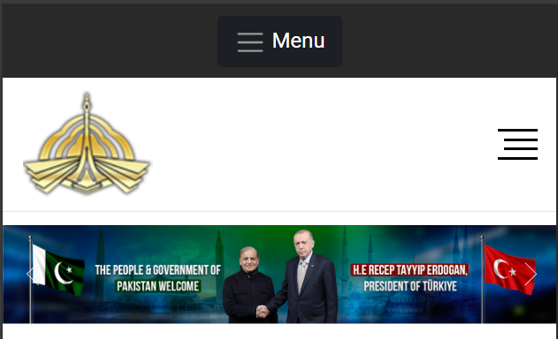

- The website's design appears outdated and does not reflect modern web design trends

Positive Things:
- The website has a straightforward, easy-to-understand layout, making it accessible to users of all ages.
- The text is easy to read due to clear fonts, which is user-friendly.
- The inclusion of images and videos adds visual interest, making the website more engaging.
- The consistent use of the PTV logo and colors helps in creating a recognizable identity.
- Information is divided into sections, which helps users find what they are looking for more easily.
Sugestion:
- Update the website to look fresh and modern.
- Make it simple for users to find what they are looking for with clear and organized menus.
- Ensure the website loads quickly by optimizing images and reducing unnecessary content.
- Use matching fonts and colors throughout the site for a professional appearance.
- Make sure the website works well on phones and tablets.

